**The Ark Documentation.**

**Inventory.**

Log in and select your study.

Once you have chosen your study we will see the following functions. Click the LIMS function in the top row.

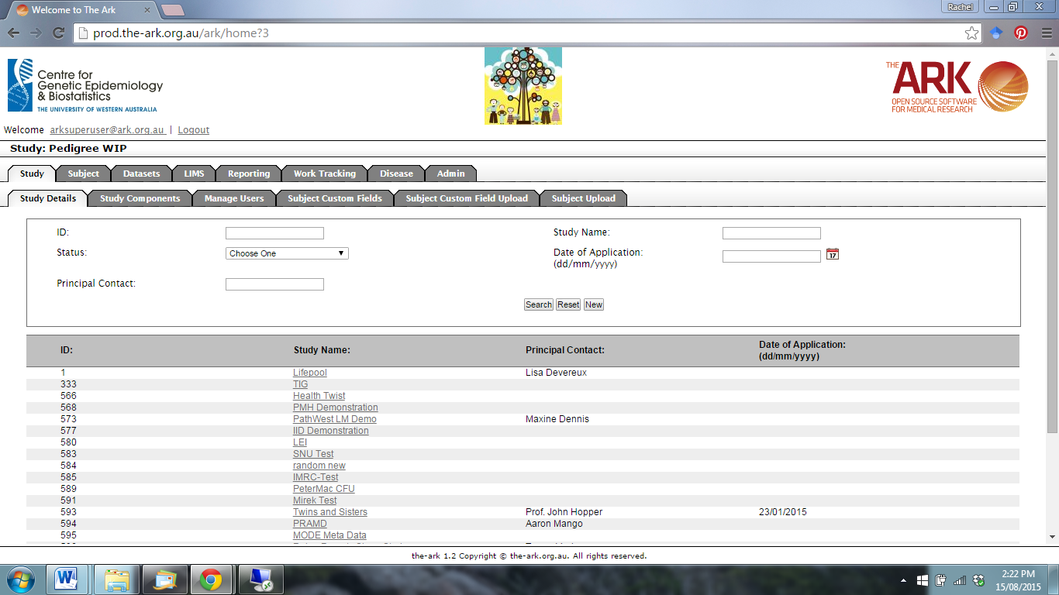

The following page will appear. You are already on the Inventory function.

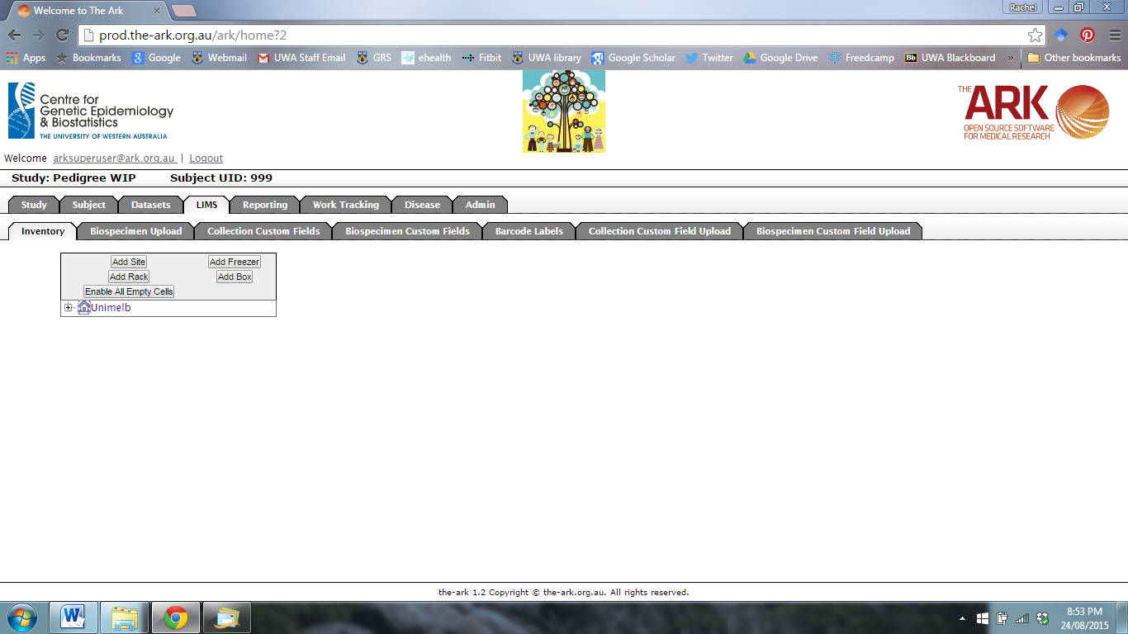

Click Add Site to add a new biospecimen storage site.



The following page will appear.

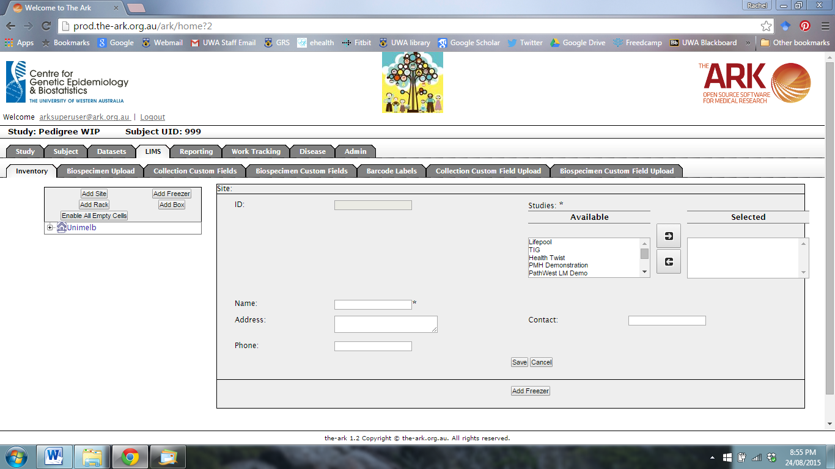

Fill in the name, address and phone information for the new site. Select an available study from the list and move to the selected side by clicking on the arrow. When you are finished, click Save.

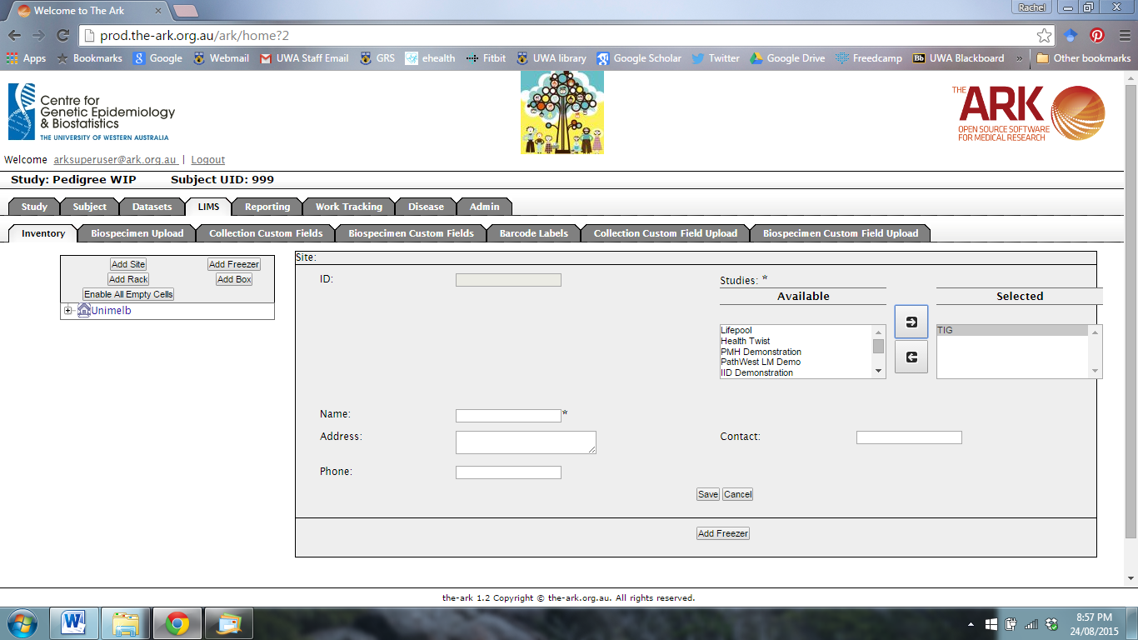

Once you have saved the new site, an option will appear at the bottom of the page to add a new freezer.

To add a New Freezer, click this button at the bottom of the screen (or on the left of the screen.)

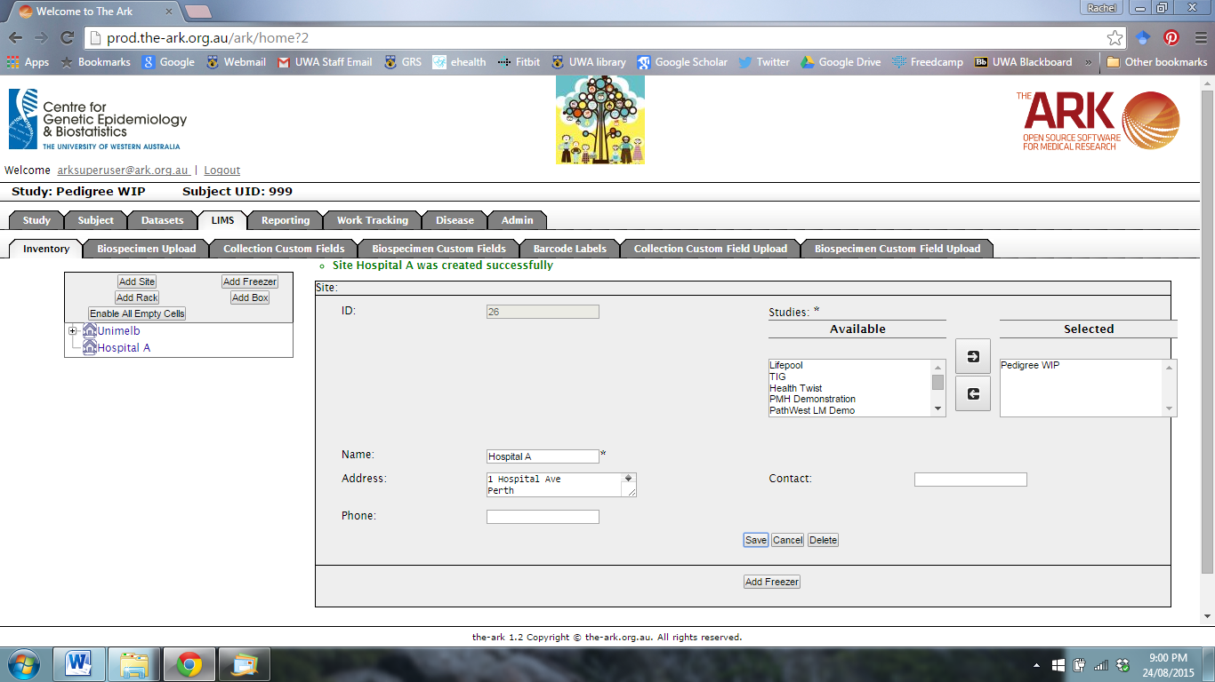

The following page will appear.

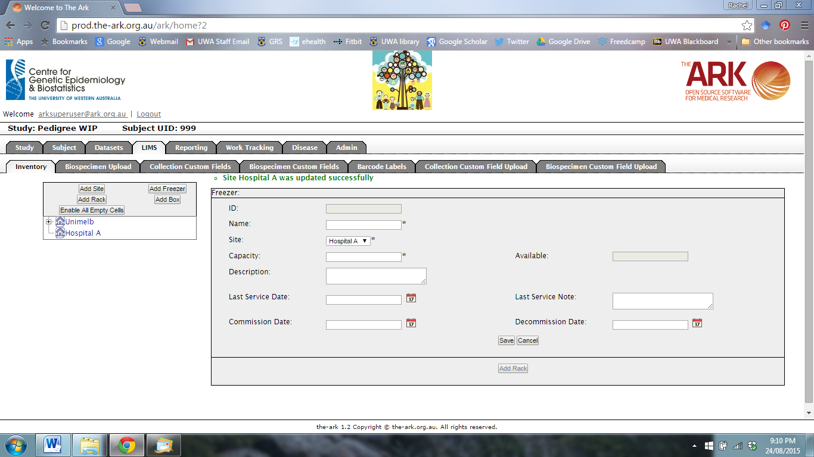

Fill in the details for the new freezer including name, site, and capacity. When you have finished, click Save.

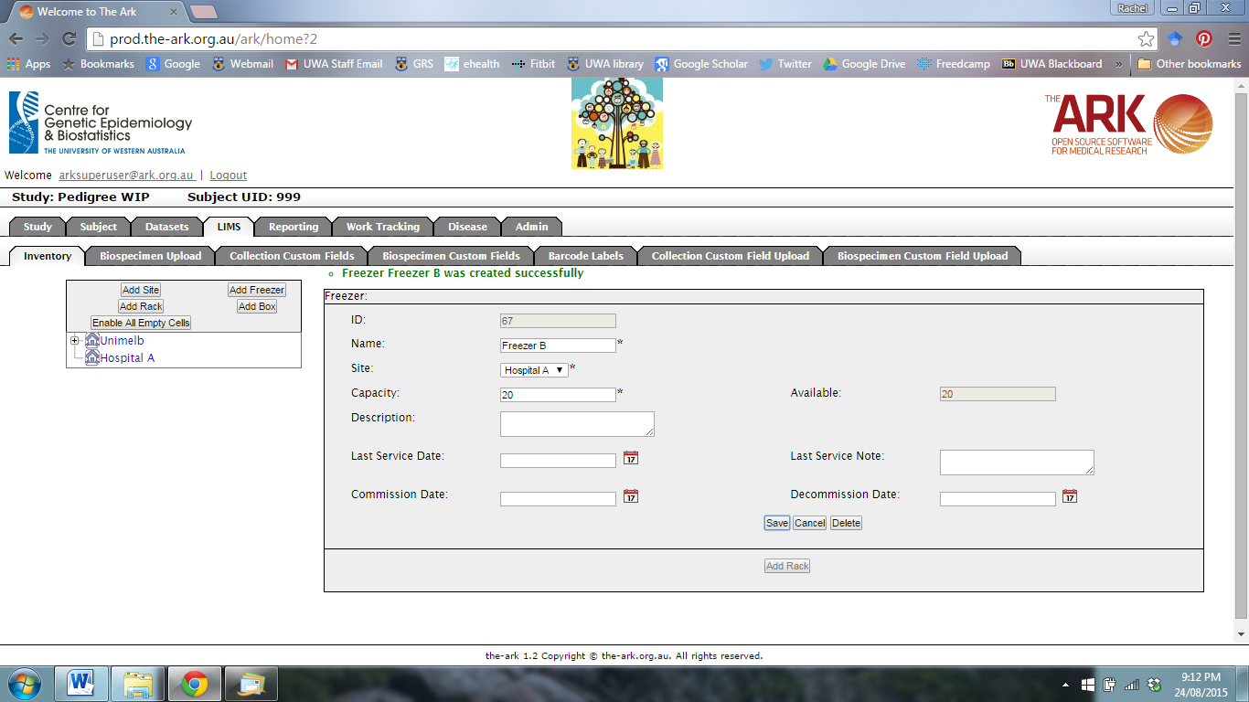

To add a new storage rack to the freezer, select Add Rack.



The following page will appear.

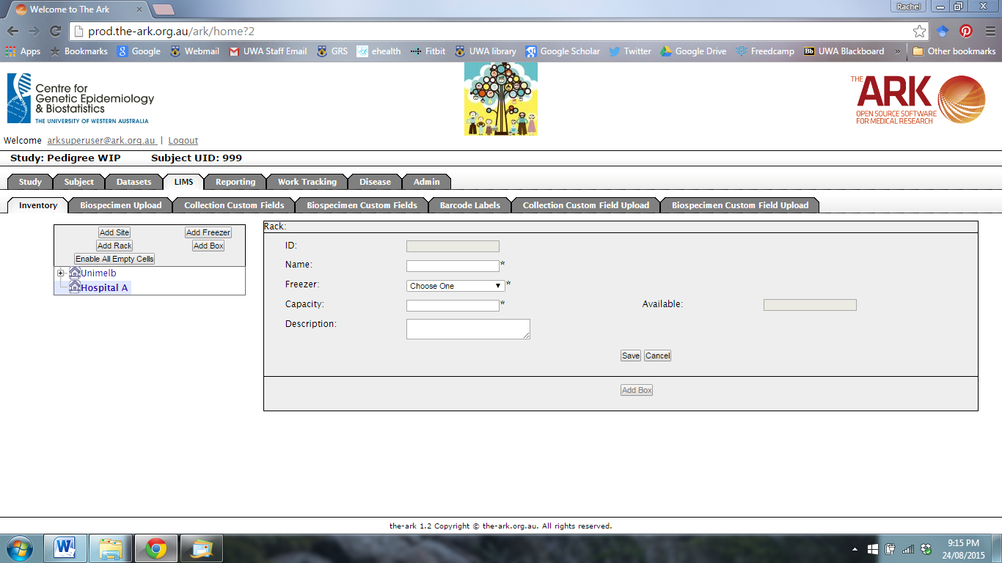

Fill in the details for the new rack. You can select the site and freezer from the drop-down menu. When you have finished, click Save.

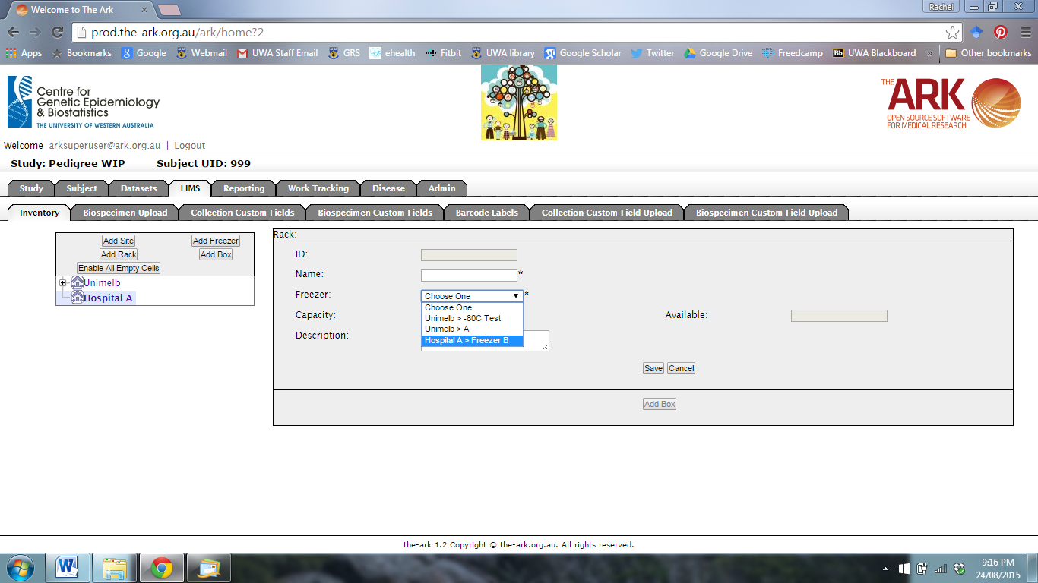

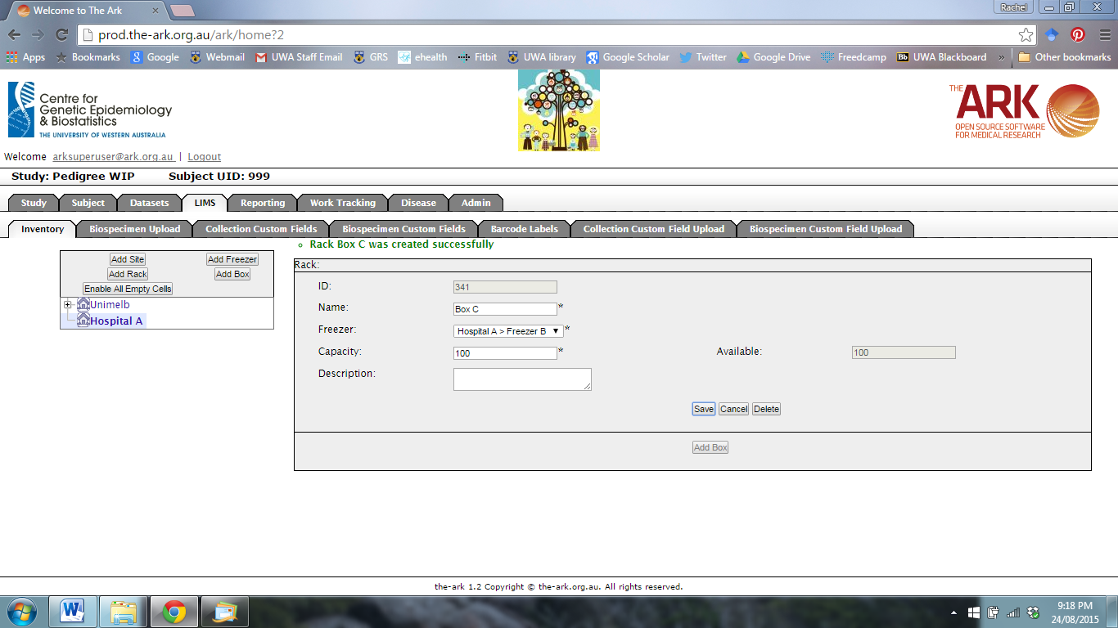

To add a new storage box to the rack, select Add Box.



The following page will appear.

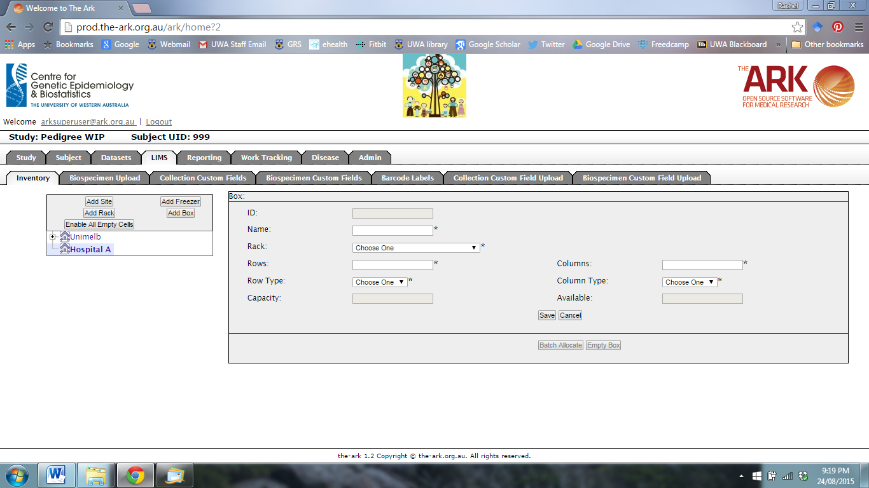

Fill in the details for the new box. You can select the site, freezer and rack from the drop-down menu.

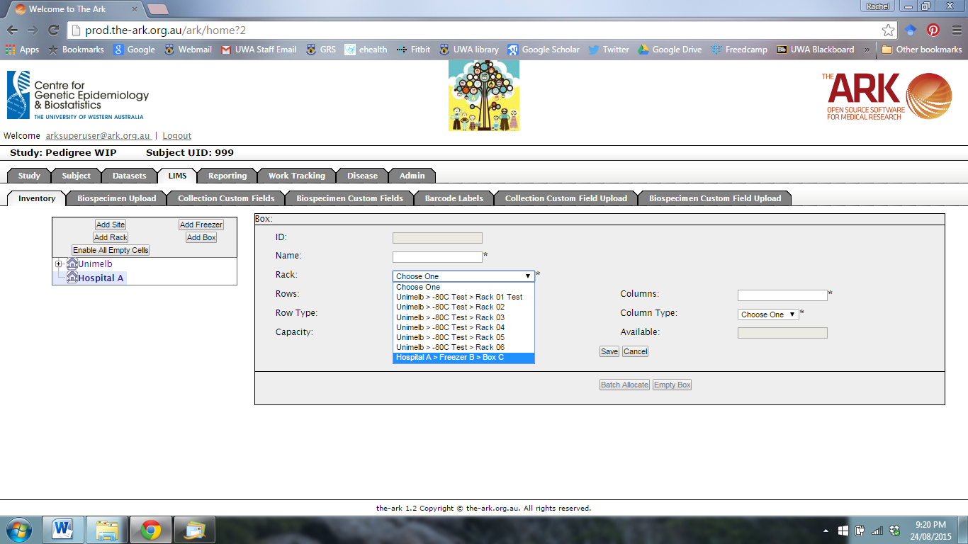

You can select the Row Type and Column Type (numeric or alphabetic) from the drop-down menu.

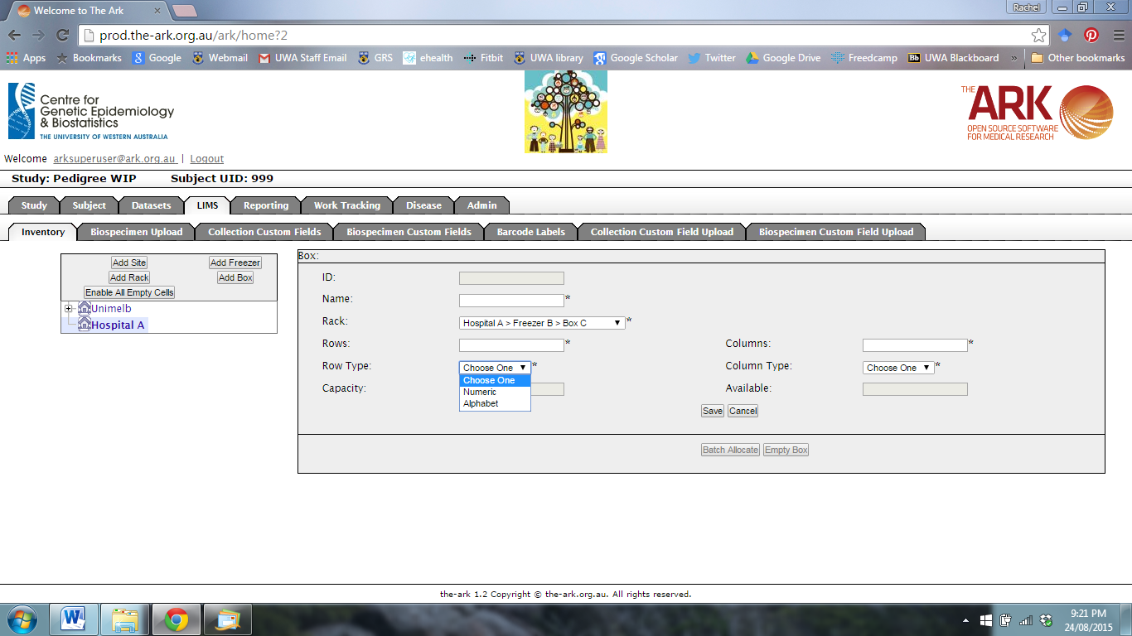

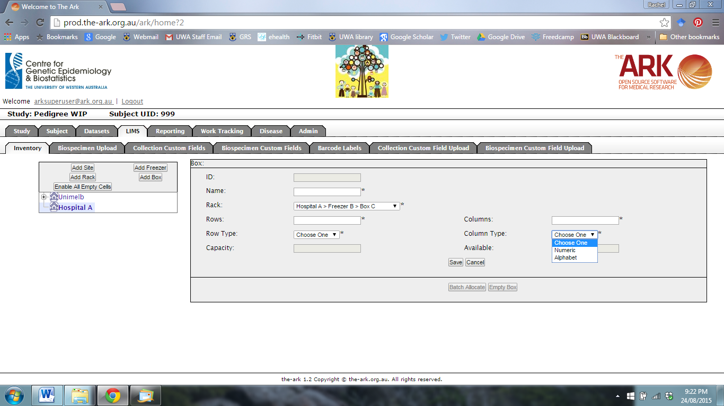

When you have finished, click Save.